Stage 6 – The Power to Transform Lives
Designed by Ike Starnes
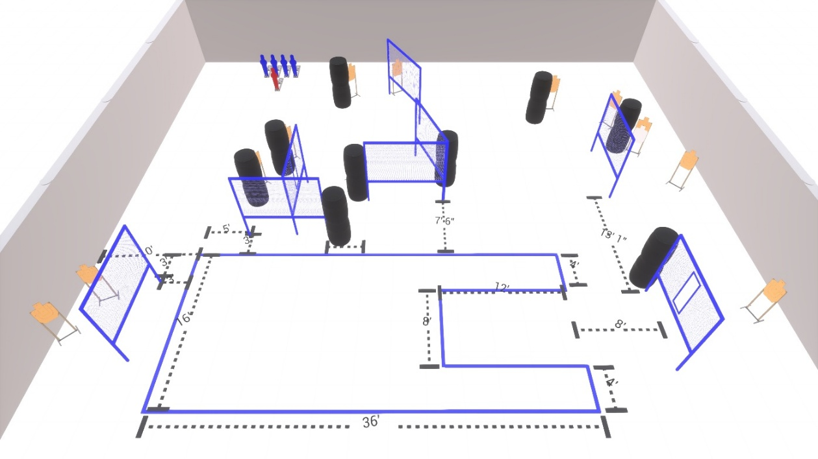
Welcome to Stage 6 - The Power to Transform Lives
Sponsored by Blue Team Shooting Sports.
I am _____________________________, the CRO for this stage and working with me are ____________________________________________________________.
Stage 6 is a 28 round Comstock course with 12 USPSA cardboard targets, 4 USPSA Poppers and 1 NS Popper.
Start position is anywhere inside the shooting area.
Handgun is loaded and holstered, with wrists below belt.
PCC is loaded with buttstock touching the belt.
At the audible start signal, engage all targets as available from within the shooting area.
Are there any questions?
You have 4 minutes to walk the stage.

